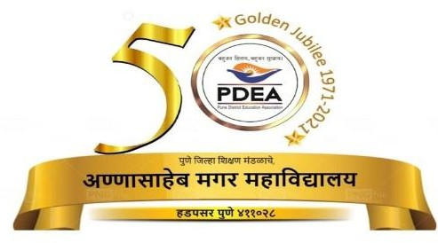

**A**

**PROJECT REPORT ON**

**“Adventure Map Web-app”**

**BACHELOR OF BUSINESS ADMINISTRATION (COMPUTER APPLICATION) SEM V**

**2024-2025**

**SUBMITTED TO**

**Savitribai Phule Pune University DEVELOPED BY**

***Buddhivant tejas Ganesh***

**&**

**Gatkul somnath dajiba UNDER THE GUIDENCE OF HOD: ASHA MANE MAM**

**Annasaheb Magar College Hadapsar Pune-411028.**

**DEPARTMENT of BBA(C.A)**



**Annasaheb Magar College Hadapsar Pune-411028.**

**DEPARTMENT of BBA(C.A)**

## CERTIFICATE

This is certified that Buddhivant tejas & Gatkul somnath students Bachelor of Business Administration (Computer Application) has satisfactory completed the project work on “**Adventure Map Web-app**” as per the syllabus laid down by the Savitribai Phule Pune University during the academic year 2024-2025

Date :-

Exam seat no Exam seat no

Project Incharge Head of Department

Internal Examiner External Examiner

**ACKNOWLEDGEMENT**

First of all while presenting this project I express my sincere gratitude to almighty god for his grace and blessing that helped me to complete this project work successfully.

We are also grateful to our teachers Prof. Asha mane mam for their encouragement, help and support from time to time I have been benefited by their valuable guidance, able support constructive suggestions and rich experience in the field of software development.

I would also like to express my deep sense of obligation and reverence to my parents for their constant support without whom this. Work not have been seen the light of the day.

I am also thanks to my teachers for their support and helping to our system project.

***Buddhivant tejas***

**Gatkul somnath**

## INDEX

|  |  |  |  |
| --- | --- | --- | --- |
| **SR NO.** | **PARTICULAR NAME** | **PA GE**  **NO** | **SIGNATURE** |
|  |  |  |  |
| **1** | **INTRODUCTIONS :-** |  |  |
|  | * 1. **Profile of system**   2. **Scope of system**   3. **Purpose of the system** |  |  |
| **2** | **SYSTEM ANALYSIS :-**   * 1. **Feasibility Study**   2. **Fact Finding Technique**   3. **Hardware and Software Requirement** |  |  |
| **3** | **SYSTEM DESIGN :-**   * 1. **Entity Relationship Diagram**   2. **Use Case Diagram**   3. **Class Diagram**   4. **Component Diagram**   5. **Deployment Diagram**   6. **Object Diagram**   7. **Data Dictonary** |  |  |
| **4** | **FORMS AND REPORT**   * 1. **Input & output screens** |  |  |
| **5** | **TESTING** |  |  |
| **6** | **ADVANTAGES & DISADVANTAGES** |  |  |
| **7** | **CONCLUSION** |  |  |
| **8** | **FUTURE ENHANCEMENT** |  |  |
| **9** | **REFERENCES** |  |  |
|  |  |  |  |
|  |  |  |  |

INTRODUCTION

Welcome to newly designed website The Adventure Map Web App is a dynamic platform designed to engage users in exploring their local environments while earning points and achievements through participation in various activities. By utilizing a user-friendly interface combined with interactive mapping technologies, this application allows users to discover nearby locations, leave feedback, and compete with friends on a breadboard.

# SCOPE OF THE SYSTEM

* **Registration and Authentication**: Users can create accounts and securely log in.
* **Profile Management**: Ability to update personal information and track points and badges.
* **Interactive Map:** Displays nearby locations with detailed information and custom markers.
* **Points and Badges:** Users earn points for visiting locations and can view badge progress.
* **Leaderboards:** Compare points with friends and other users.
* **Exploration Challenges:** Participate in challenges for additional points and badges.
* **Reviews and Feedback**: Leave reviews and ratings for visited locations.

# PURPOSE OF SYSYTEM

The Adventure Map Web App is designed to encourage exploration and foster a sense of adventure by motivating users to discover and engage with nearby locations. Through gamification, the app incorporates a points and badges system, making participation in activities and challenges enjoyable and rewarding. It promotes community building by allowing users to share their experiences through reviews and feedback, creating a network of explorers who can learn from one another. Additionally, the app highlights local businesses and attractions, driving traffic to these locations. User engagement is enhanced through features like leaderboards and exploration challenges, fostering competition and social interaction among users. The system also collects valuable data on user preferences and behaviors, enabling improvements and personalized experiences. An administrative interface allows for effective management of users, locations, and content, ensuring the app remains safe, relevant, and user-friendly. Overall, the Adventure Map Web App aims to enrich users' experiences while providing essential tools for managing and promoting local attractions.

# SYSTEM ANALYSIS

**FEASIBILITY STUDY**

### Economical feasibility : -

Economical analysis is the most frequently used technique for evaluating the effectiveness of a proposed system. If benefits outweight costs, a decision is taken to design and implement the sysyem.

### Technical Feasibility : -

This is concerned with specifying equipment and software that will successfully satisfy the user requirments . The technical needs of the system may very considerably, but might include

Facility to communicate data to distant locations. Response time under certain conditions.

### Operational Feasibility:-

This is mainly related to human organizational andpotical aspects. The points to be considered are:

What changes will be brought with the system ? What organizational structure is disturbed

1. **Social feasibility :** Social feasibility is a detailed study on how one interacts with others within a system or an organization.

# Fact Finding Technique

* **Interviews**:
  + Conducting one-on-one or group interviews with stakeholders, such as users, administrators, and business owners, to gather detailed insights and requirements.
  + Pros: Direct feedback, ability to clarify doubts, and explore in-depth issues.
  + Cons: Time-consuming and may be biased based on the interviewee’s perspective.
* **Surveys and Questionnaires**:
  + Distributing structured surveys or questionnaires to a larger audience to collect quantitative data about user needs and preferences.
  + Pros: Can reach a wide audience quickly and provide statistical data.
  + Cons: Limited depth of information and potential misunderstanding of questions.
* **Observation**:
  + Observing users as they interact with existing systems or perform relevant tasks to understand workflows and pain points.
  + Pros: Provides real-world insights into user behavior and system usage.
  + Cons: May not capture the full context or reasons behind actions.
* **Document Analysis**:
  + Reviewing existing documentation, reports, user manuals, and system specifications to understand current functionalities and requirements.
  + Pros: Provides background information and identifies existing issues or gaps.
  + Cons: Documents may be outdated or incomplete.

**HARDWARE & SOFTWARE REQUIREMENT**

## HARDWARE :-

1. Intel Pentium 3 processor or higher
2. RAM 256 MB
3. 40 GB HDD (Hard Disk)
4. CD Drive 16X or higher

## SOFTWARE :-

1. OPERATING SYSTEM : MICROSOFT WINDOWS.
2. FRONT END TOOL : COREJAVA .
3. BACK END : MYSOL .

# SYSTEM DESIGN :-

* + 1. Entity Relationship Diagram

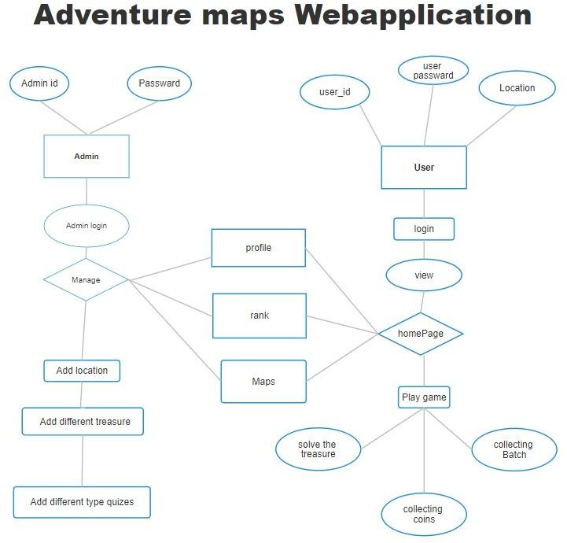

* + 1. Use Case Diagram

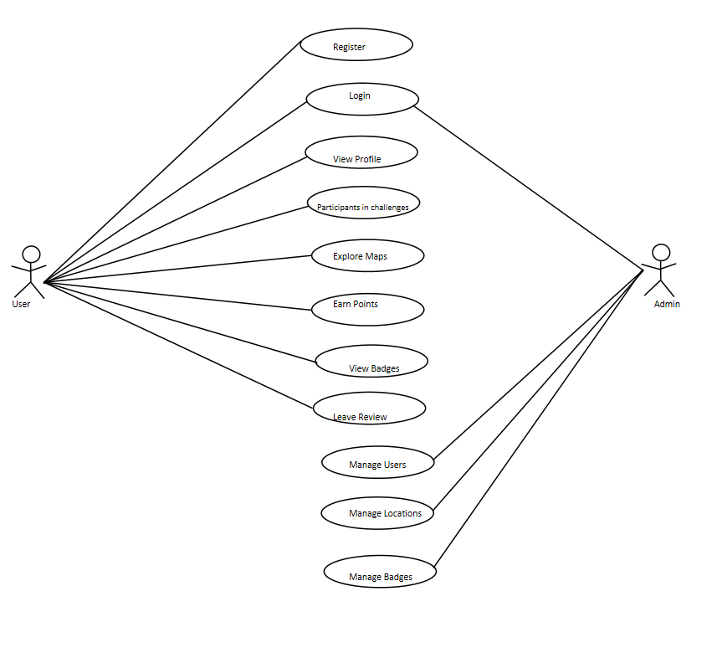

* + 1. Class Diagram

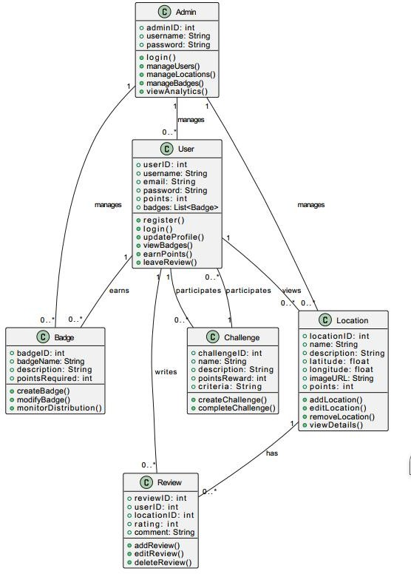

* + 1. Component Diagram

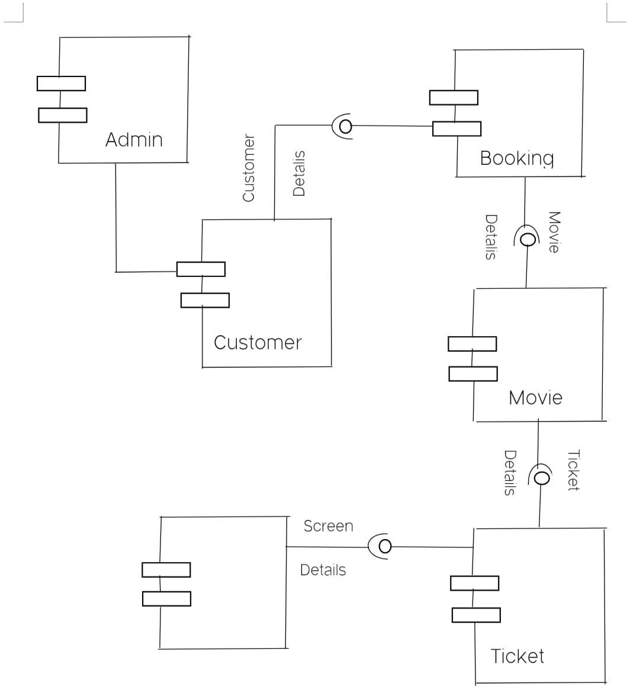

* + 1. Deployment Diagram

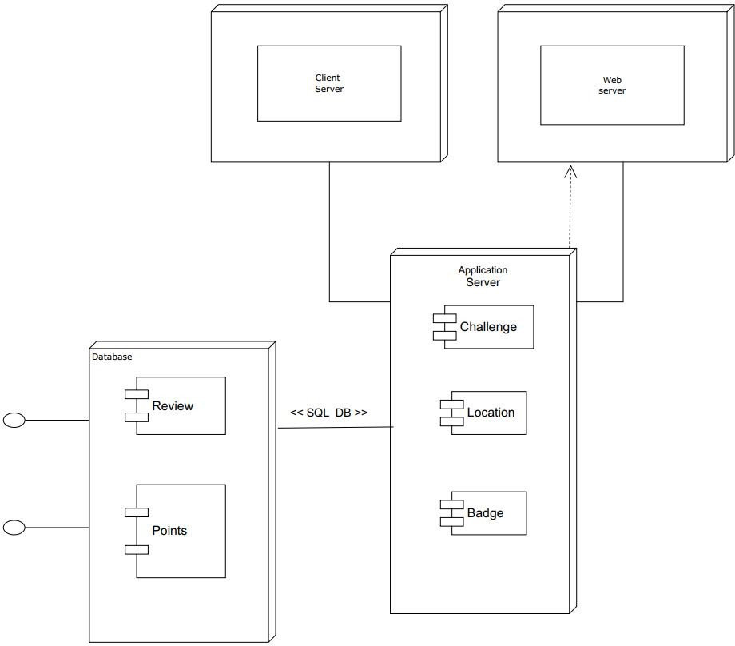

* + 1. Object Diagram

